PRESS RELEASE
COMMUNICATIONS AND MEDIA TEAM OF THE 43RD ASEAN SUMMIT 2023
No.84/SP/TKM-ASEAN2023/ENG/9/2023

President Jokowi: AIPF will Strengthen ASEAN Position as World Growth Center
JAKARTA, SEPTEMBER 5, 2023 - President Joko Widodo officially opened the ASEAN-Indo-Pacific Forum (AIPF) in Jakarta on Tuesday (5 September 2023) and hailed the inaugural regional event as a concrete implementation of the ASEAN outlook on Indo Pacific as well as an effort to strengthen ASEAN as a world growth center.
“It is an honor for Indonesia to welcome you to the ASEAN-Indo-Pacific Forum,” Widodo said, addressing the guests made up of leaders of ten ASEAN state members and representatives from other regional countries.
ASEAN outlook on the Indo-Pacific envisions a perspective of viewing the Asia-Pacific and Indian Ocean regions, not as contiguous territorial spaces but as a closely integrated and interconnected region, with ASEAN playing a central and strategic role in dialogue and cooperation as well as putting the importance of the maritime domain and perspective in the evolving regional architecture.
Among non-ASEAN countries attending the opening ceremony were China, Japan, Australia, South Korea, Canada, Timor Leste, India, United Kingdom and New Zealand.
The two-day forum, which is a flagship event of the ASEAN and East Asia Summits, runs for two days until Wednesday at Mulia Hotel, Jakarta.
The event is being held in the aftermath of Covid-19 pandemics which has largely brought adversities on global economy.
“In the midst of the weakening world economy, the ASEAN economy has proven to be resilient and continues to grow, outpacing the growth of the global economy in other regions,” he said.
While pointing to the region’s 680 million population as being one of the factors that made it a huge potential market with promising investment opportunities, the president conceded the region has been facing various global challenges, including the geopolitical rivalries, especially the potential for conflict in the Indo-Pacific region.
“For this reason, the ASEAN-Indo-Pacific Forum is here to turn rivalries in the Indo Pacific into fruitful cooperation,” he said.
“Through this Forum, we build a habit of cooperation under win-win formula without anyone feeling overlooked,” President Widodo added.
The AIPF meeting revolves on three main agendas, which he said was based on forward-looking spirit of cooperation to lay a strong foundation for future economic growth. Those agendas are green infrastructure and a resilient supply chain; sustainable and innovative financing; digital transformation and the creative economy.
He appreciated ASEAN countries and partners for the support and contribution to the ASEAN-Indo-Pacific Forum, which has resulted in 93 collaborative projects worth USD38.2 billion and 73 potential projects worth USD17.8 billion.
“This reflects our commitment, which is to walk the talk. To build a peaceful, stable and prosperous Indo-Pacific, ASEAN will continue to openly collaborate and forge inclusive cooperation while strengthening strategic trust in the Indo-Pacific,” he said.
Meanwhile, State-Owned Enterprises (SOEs) Minister Erick Thohir, in his welcoming speech, reminded the audience that the AIPC was a moment of significance, opportunity and responsibility.
“We gather to forge a path towards a future that is more connected, more prosperous, and more sustainable for the ASEAN and Indo-Pacific regions,” he said.
He praised President Jokowi for his commitment guiding in the efforts to strengthen regional cooperation and promote a more sustainable development.
“As we assume the ASEAN Chairmanship this year, we are inspired by his commitment to making ASEAN a true epicenter of growth,” said Thohir.
According to Minister Thohir, the Indo-Pacific, which represents over 60% of the global Gross Domestic Product (GDP) and nearly half of the world's trade, is a crucible of trade, investment, and innovation.
This forum, which serves as a platform for constructive discussions, the genesis of concrete projects, and the enhancement of collaboration in the Indo-Pacific, is seen as an embodiment of collective response to the region's challenges and opportunities and a commitment to a rule-based, open, and inclusive regional order.
“As we convene in this venue, concurrently with the 43rd ASEAN Summit and East Asia Summit, the imperative of collaboration and dialogue is underscored,” he said.
Indonesia, which contributes 35.4% to the ASEAN region's GDP, is looking to play a proactive and supportive role to help the region thrive.
“Despite the global economic headwinds, our 5.17% year-on-year growth in the second quarter of 2023 stands as a beacon of our ongoing recovery and resilience.
“This achievement is a testament to the strength of collaboration not just within our government, state-owned enterprises, and the private sector, but also with our partners in the ASEAN and Indo-Pacific regions,” Minister Erick Thohir said.
***
For more information, please contact:
Director General of Information and Public Communication, Ministry of Communication and Information – Usman Kansong (0816785320).
More information, please visit http://asean2023.id, https://infopublik.id/kategori/asean-2023, dan https://indonesia.go.id/kategori/ragam-asean-2023
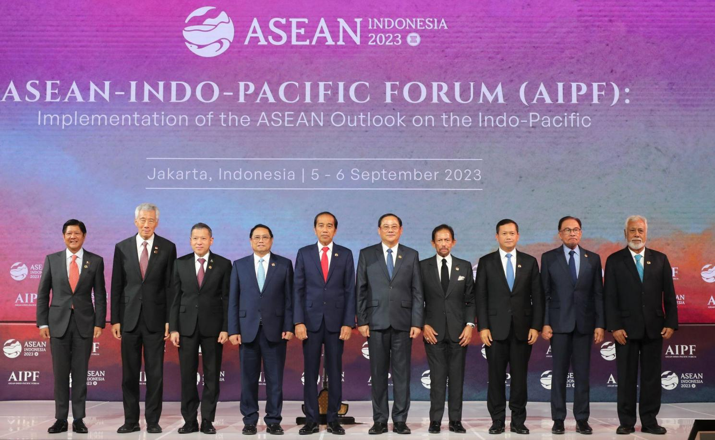
ASEAN state leaders at the opening of ASEAN Indo-Pacific Forum (AIPF)
(Photo: Media Center KTT ASEAN 2023/Risa Krisadhi/pras)

